Filedaria Inc
A Happy and Beautiful Experience with us
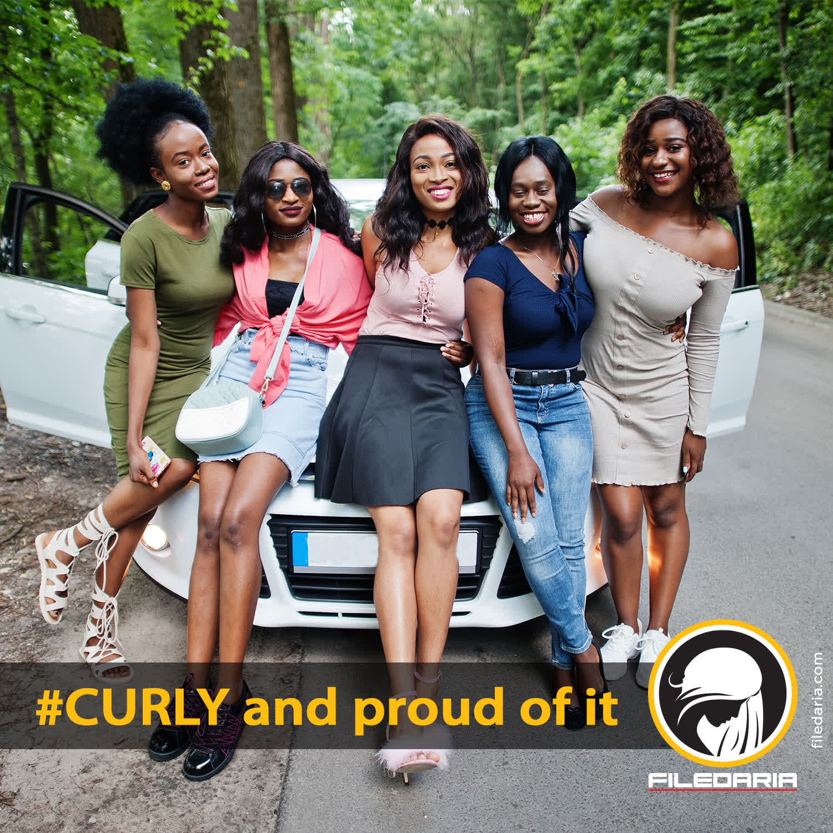
About us
Filedaria Inc is well-known and highly recognized as a leading afro-textured hair salon and offers a full line of solutions in the hair salon industry. We have been in this business for more than 10 years and offer the best salon and hair products services to every customer. We understand our customers' naturally curly hair issues and strive to give them hair services that exceed their expectations. Learn more!

Afro Hair Love Products
All Afro Love hair products are free from Salt, Parabens, Silicone & Mineral Oils (Petroleum) and make your hair shiny, silky, and smoothy. Buy online!
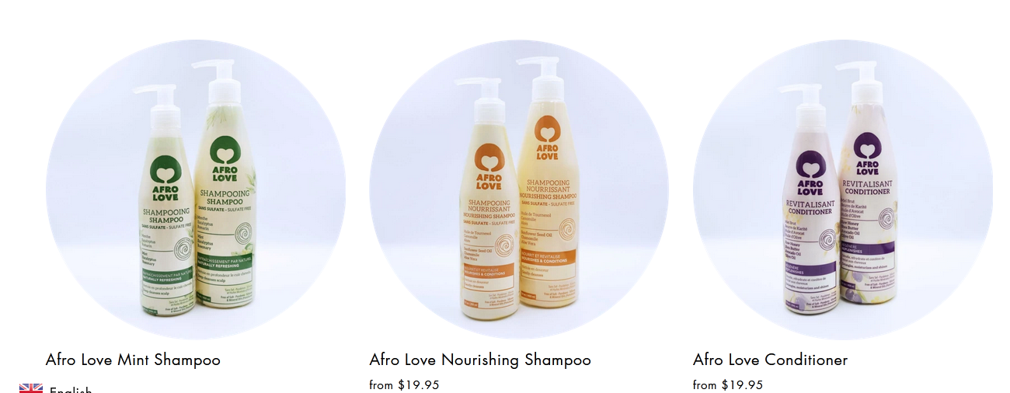

Black Hair Salon Brampton

Do you want to cut your curly hair at the best salon? Then visit our famous black hair salon in Brampton, and take your desired hair cut at a low price. Visit today!

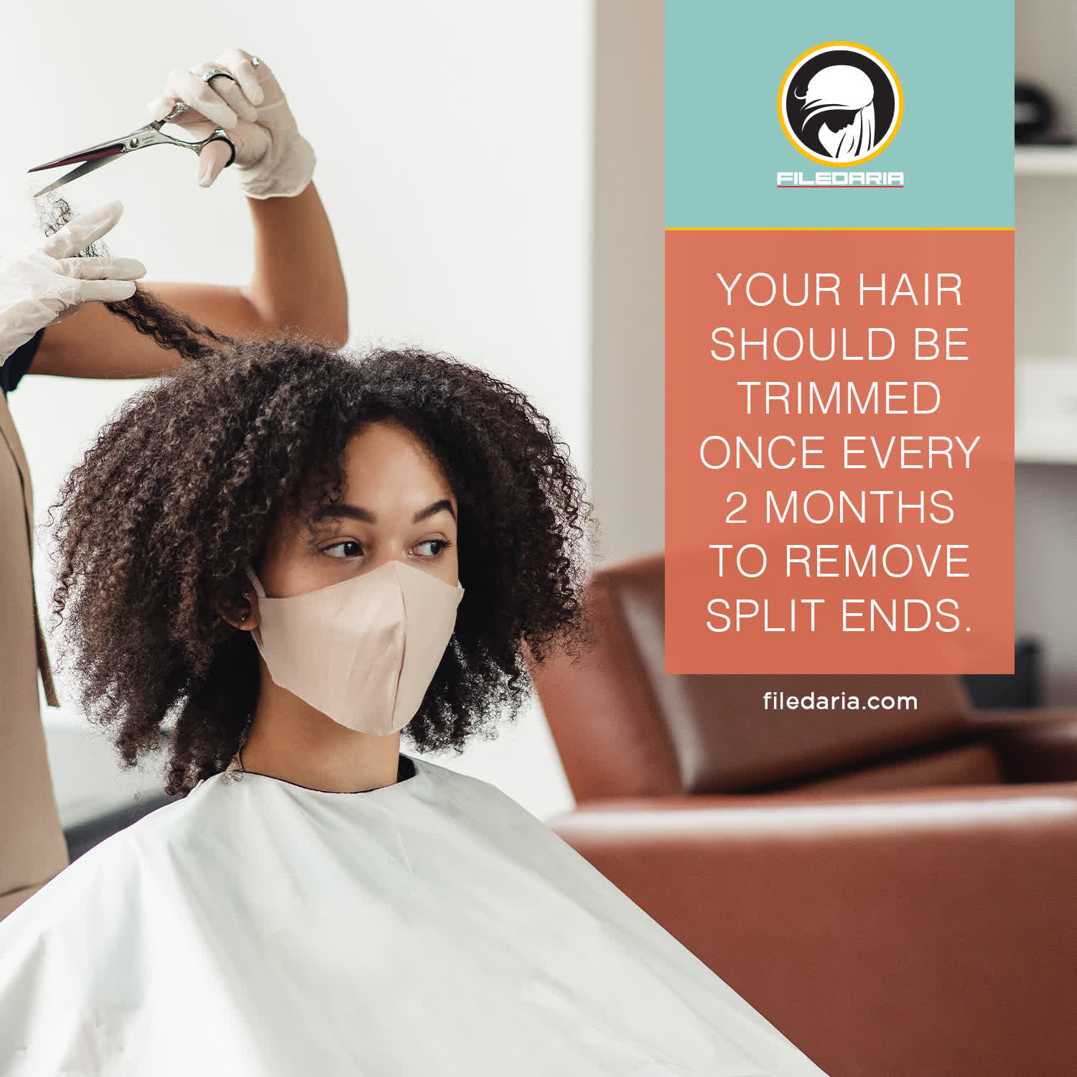
Black Hair Salon Hamilton

Do you want to do Crochet Braids for your afro-textured hair? Visit our best-rated black hair salon in Hamilton and check the services menu: twist, twist-outs, single braids, and box braids for $100/hour. Don't be late, order now!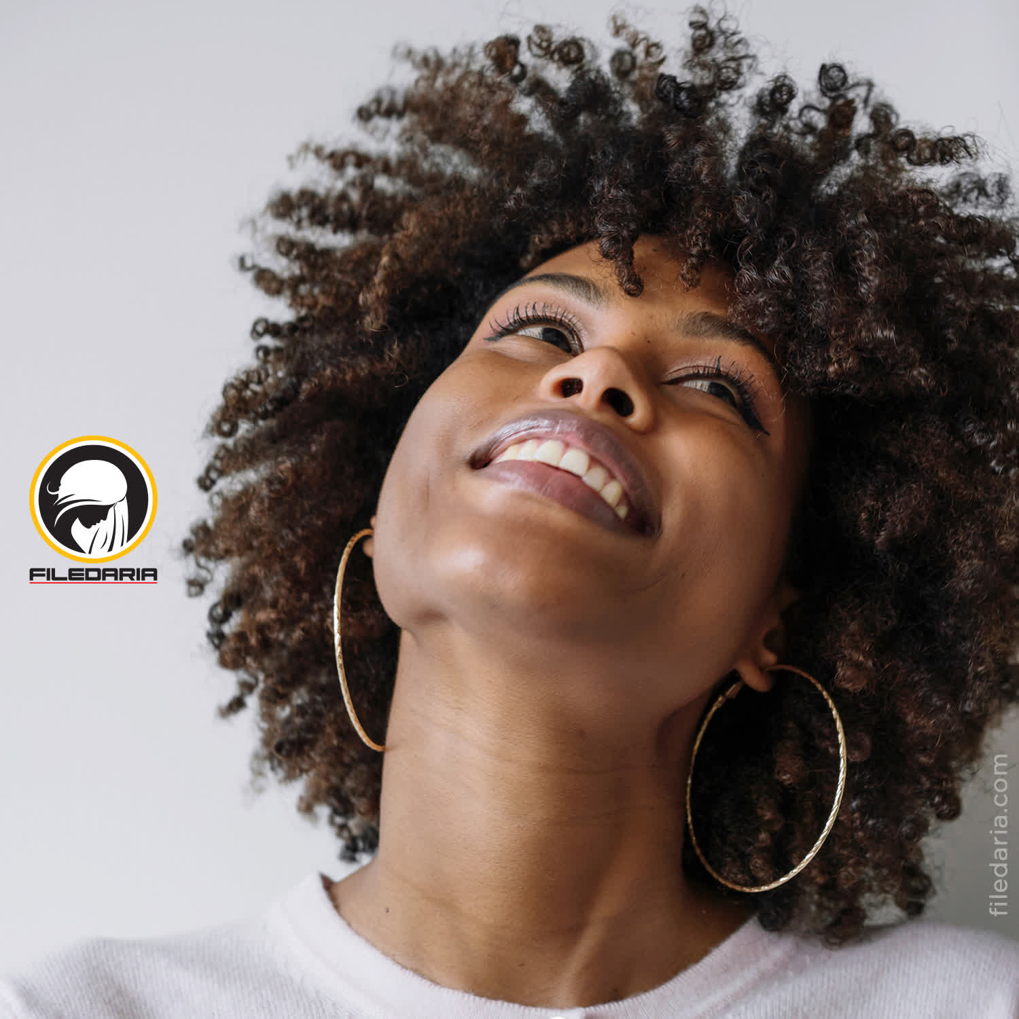

Make a visit today!
Filedaria Inc
Phone No:. 9058250428
E-mail: filedariaca@gmail.com
Website: https://filedaria.com
Address:116 Bronte Rd, Oakville, ON L6L 3C1, Canada

